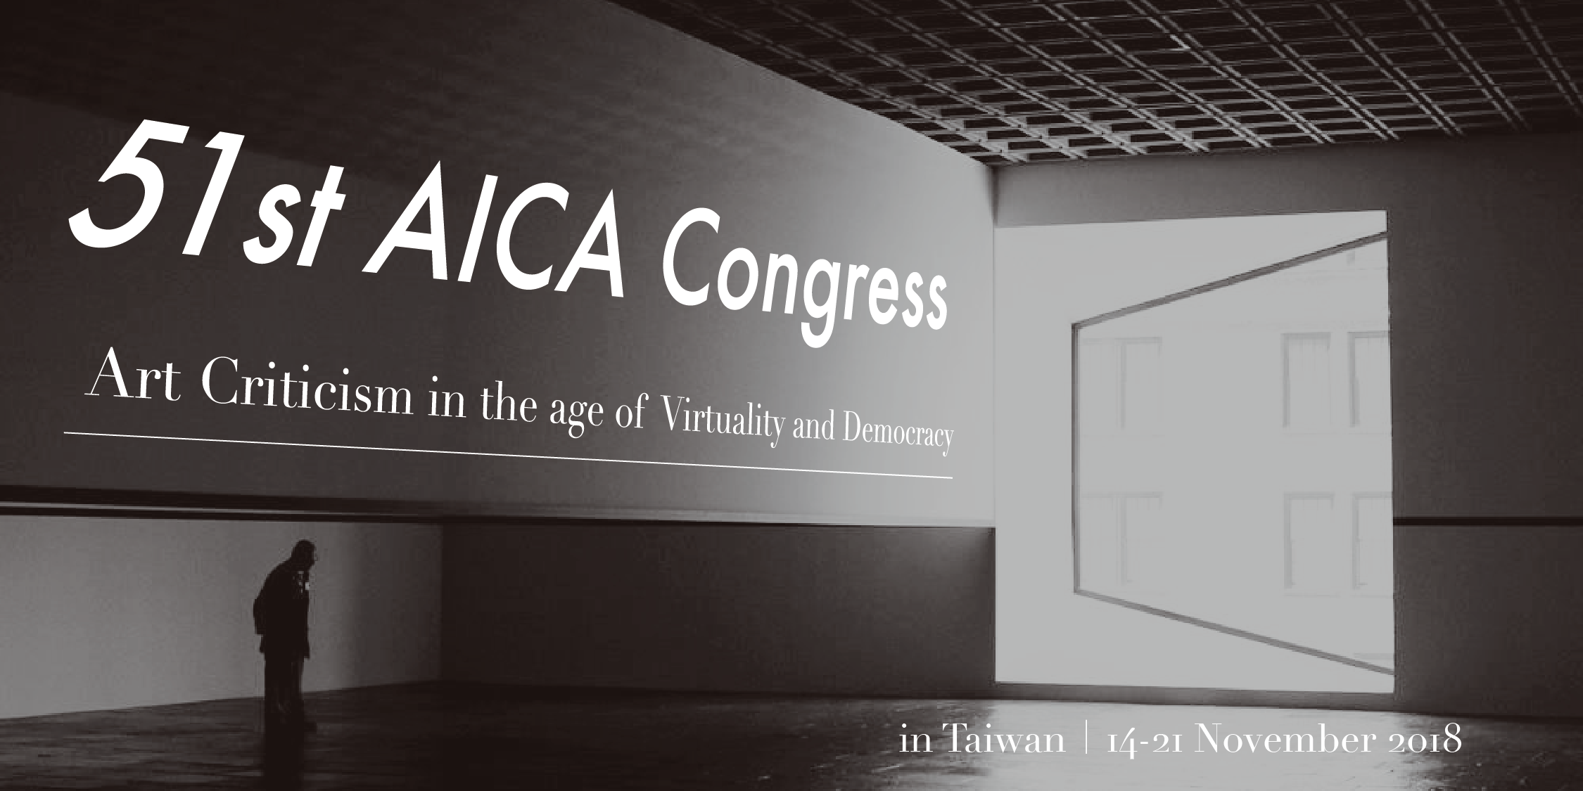

Call for Papers for the 51st AICA International Congress in Taiwan
14-21 November 2018

We would like to cordially invite you to take part in the 51st AICA International Congress. The Congress is organized by the Taiwan section of AICA (International Association of Art Critics) and will be held on 14-21 November, 2018 in Taiwan, the draft program as follows:

Nov. 14 Committees (in Taipei)
Nov. 15 General Assembly & Board Meeting (in Taipei)
Nov. 16-18 Symposium (in Taipei)
Nov. 19-21 Post-Congress Trip (in Taichung, Tainan, Kaohsiung)

The Congress Theme Art Criticism in the age of Virtuality and Democracy addresses some key issues concerning the role of art criticism related to the new tendencies. The congress theme has two sub-themes:

- Art criticism in the age of virtuality
- Art discourse facing challenged democracy
(A detailed description of the congress theme is given below. *)

The symposium will be held mainly in English, and the papers should be presented in English only. Keynote speakers, covering broad aspects of the main theme will be followed by short papers and working sessions with the participants.
The AICA Congress Committee invites members, as well as non members, of AICA to submit a short text of 15-20 lines (maximum one page) in English, outlining their proposed approach to the themes of the Congress.
Deadline
Please submit your application online at aicacongress2018@gmail.com together with a short biography (max. 200 words) by 31 May 2018. Proposals will be selected by the AICA committee.
Deadline for final papers will be 15 August 2018.
Visuals
There will be video/audio equipment available for lectures, we invite all speakers to support their presentation by visuals.
Translation
Speakers’ final papers must be submitted by the deadline in English. These papers will be translated by the organizers into Traditional Chinese, if the budget allows, and distributed at the time of the Congress.
Publication
The Collection of Papers is estimated to be published by AICA Taiwan in 2019.
Website
You will find all necessary information at https://aicataiwan.blogspot.tw/

Contact Person
Tien-Han Chang
aicacongress2018@gmail.com
Crucial Reminder
Main Theme: Art Criticism in the age of Virtuality and Democracy
Sub-Themes: a. Art criticism in the age of virtuality
b. Art discourse facing challenged democracy
Deadline for call for papers (Abstract): 31 May 2018
Deadline for final papers of selected speakers: 15 August 2018

For any inquiries please feel free to contact us, thank you and we expect for your participation.

51st AICA International Congress in Taiwan,
14-21 November 2018
AICA Taiwan
AICA Congress Taiwan November 2018
Congress theme for Call for Papers:

Art Criticism in the age of Virtuality and Democracy
Based on observations of important tendencies in the actual world, we would like to address some key issues concerning the role of art criticism related to these new developments.

Firstly, the virtual is not the opposite of reality but rather an increasing part of our reality. Presently, communities, social relations, everyday life, the body, and even biological life are in the processes of mass virtualization. Life itself has been supposed as an algorithm, AI as a brain without body, while space-time’s relationship is virtualized in VR technology. A virtual enterprise need no longer convene its employees onsite, but rather can delegate work to be done remotely, thus re-articulating the time-space relationship of its workers.

Secondly, if we make an observation of a longer duration, there seems to be an unquestionable expansion of democracy which can be confirmed by the democratic transitions beginning in the mid-1970s, which span from Latin America to Taiwan and South Korea, through the end of the cold war, and to following transitions in Eastern Europe, the Color Revolution and the Umbrella Movement in Hong-Kong in the fall of 2014. Nevertheless in more recent years, the phenomenon of the retreat of democracy can also be observed in the uprising of the populism worldwide.

Moreover, these two tendencies may be related. The Congress Theme “Art Criticism in the age of Virtuality and Democracy” has two sub-themes:

- Art criticism in the age of virtuality
- Art discourse facing challenged democracy

- “Art criticism in the age of virtuality” will address the situation in which the rapid pace of development in computer and media technologies is creating new working environments and new possibilities for art, each with their own particular problematics. How does this process affect the description, interpretation and evaluation of contemporary art? More precisely, does art criticism develop new methodology and new languages concerning its analysis and new problematics in its debates? What does it mean for art and art criticism that new media reaches crowds of new readers around the world, often “for free”?

- “Art discourse facing challenged democracy” will discuss the following questions: how is art discourse constitutive of the collective representations and imaginary of democracy? In the situation of democracy under challenge, how are these social-political phenomena reflected in new developments of censorship and self-censorship, or post-truth? For new problems brought out by transitional justice, what kind of function can art discourse play?

Proposals of papers which could articulate the problems within these two sub-themes will also be welcome.

